

OFS

-Keerthikha

Document Version / Details: Ver. 2.0/ 14-Nov-2022

WORD DOCUMENT

Agenda:

1. What is OFS
2. Type of Request
3. Types of Mode in OFS
4. OFS structure for Transact request/Response and Enquire request/Response
5. Success indicator
6. GTS control
7. NAU processing
8. Create OFS for AA.ARRANGEMEMT
9. Special character
10. Routines

**What is OFS?**

OFS is the interface that provides a single point of entry to temenos transact, which means that every interaction with Transact is driven through OFS.

OFS does work like request response system, any system can request data from T24 in OFS format and T24 will response that request.

**Types of Request**

Transaction request - create, modify or delete a record in any application in Transact.

Enquiry request - which queries data from Transact.

**Type of OFS Mode?**

Online processing signifies that is a request is sent, processed immediately and the response sent back to the requestor.

TELNET mode - for processing messages from third party systems.

SESSION mode - for processing messages from browser.

**OFS structure for Transact request/Response and Enquire request/Response**

Transact Request syntax: Operation , Options , User information , Transaction Id , Message Data

Transact Response syntax: Transaction ID / Message ID / Success Indicator / Acceptance Indicator , Re­­Data

Enquiry Request syntax: ENQUIRY.SELECT , , User information , Enquiry name , Message Data(Message data may occur many times.)

Enquiry Response syntax: HEADER CAPTION DETAILS, COLUMN DETAILS, RESPONSE DATA.

**Success Indicator**

1: Successful Transaction

-1: Error Encountered

-2: Override condition encountered.

-3: System offline

Types of Requests in OFS:

Transaction Request: Create, Modify, or delete a record in any application in T24.

Enquiry Request: Queries data from T24.

GTS.CONTROL

|  |  |  |
| --- | --- | --- |
| GTS.CONTROL | ERROR/OVERRIDE | Description |
| NULL | Error | Reject record and return error response |
| Override | approve automatically and commit |
| 1 | Error | $NAU file with status hold. |
| Override | approve automatically and commit |
| 2 | Error | Reject record & return error response |
| Override | $NAU file with status hold |
| 3 | Error | $NAU file with status hold |
| Override | $NAU file with status hold |
| 4 | All transaction | write all transactions into $NAU file with status HOLD |

Workshop

GTS.CONTROL: Null * Override

FUNDS.TRANSFER,TEST2/I/PROCESS/1/0,INPUTT/123456,,TRANSACTION.TYPE=AC,DEBIT.ACCT.NO=100013,DEBIT.CURRENCY=USD,CREDIT.ACCT.NO=100064,CREDIT.CURRENCY=USD,CREDIT.AMOUNT=10

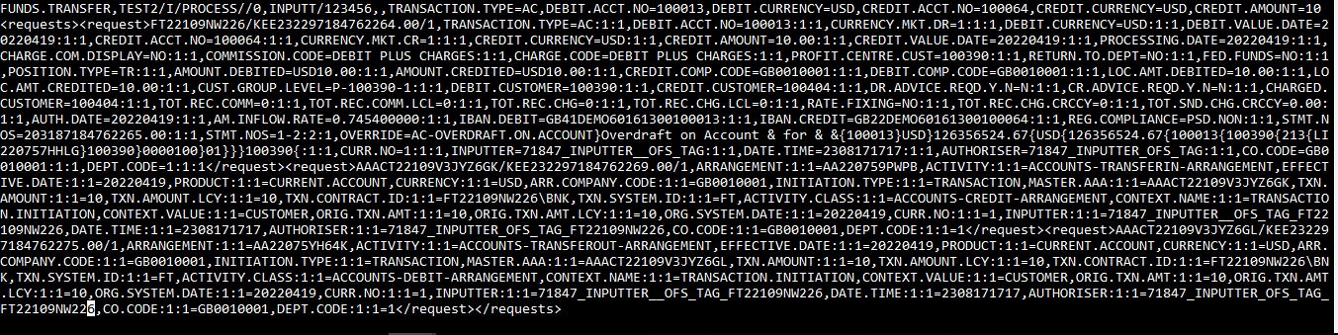

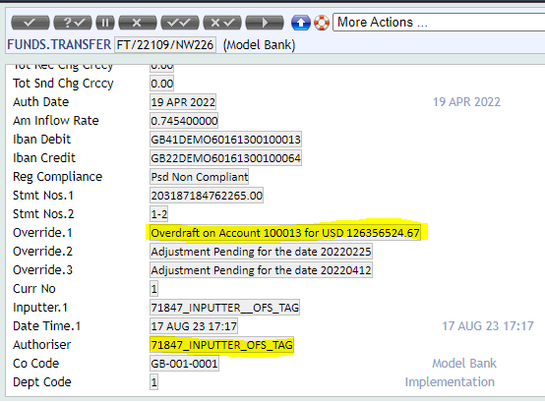

GTS.CONTROL: Null * Error

FUNDS.TRANSFER,TEST2/I/PROCESS//0,INPUTT/123456,,TRANSACTION.TYPE=AC,DEBIT.ACCT.NO=100013,DEBIT.CURRENCY=USD,CREDIT.ACCT.NO=100064,CREDIT.CURRENCY=EUR,CREDIT.AMOUNT=10



GTS.CONTROL: 1 * ERROR

FUNDS.TRANSFER,TEST2/I/PROCESS/1/0,INPUTT/123456,,TRANSACTION.TYPE=AC,DEBIT.ACCT.NO=100013,DEBIT.CURRENCY=USD,CREDIT.ACCT.NO=100064,CREDIT.CURRENCY=EUR,CREDIT.AMOUNT=10



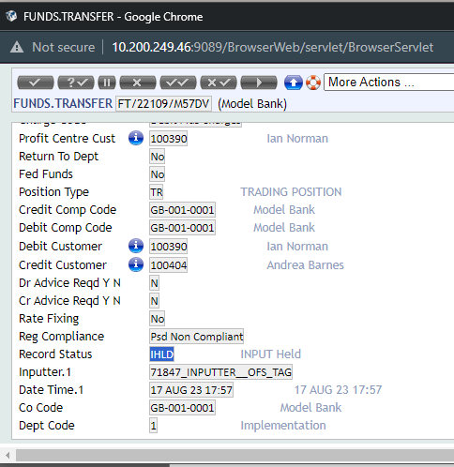

GTS.CONTROL: 2 * Override

FUNDS.TRANSFER,TEST2/I/PROCESS/2/0,INPUTT/123456,,TRANSACTION.TYPE=AC,DEBIT.ACCT.NO=100013,DEBIT.CURRENCY=USD,CREDIT.ACCT.NO=100064,CREDIT.CURRENCY=USD,CREDIT.AMOUNT=10



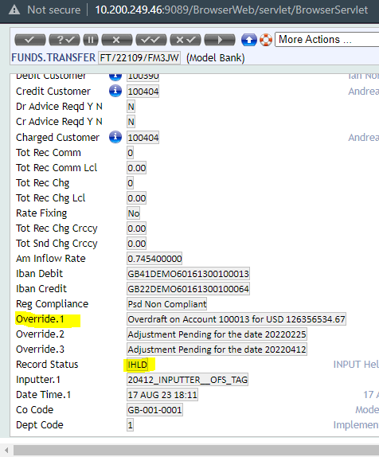

# Special character

CUSTOMER,HDFC/I/PROCESS//0,INPUTT/123456,,MNEMONIC=KEER123,RESIDENCE=IN,SECTOR=1000,ACCOUNT.OFFICER=1,INDUSTRY=1000,TARGET=1,NATIONALITY=IN,CUSTOMER.STATUS=1,SHORT.NAME:1=KEERTHIKHA?/?MAHESH123,NAME.1:1=KEEKIS

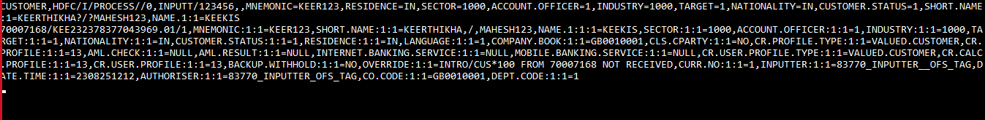

NAU PROCESSING

Optional functionality for processing of transactions via OFS where $NAU record exists.

0 – Reject messages where an NAU record exists

1 – overwriting the NAU record

2 – Delete of NAU record; reversal of live record

3 – Apply both 1 and 2

NAU PROCESSING = 0,

1. Create a record in customer.

CUSTOMER,HDFC/I/PROCESS//1,INPUTT/123456,,MNEMONIC=KEER09,RESIDENCE=IN,SECTOR=1000,ACCOUNT.OFFICER=1,TARGET=1,NATIONALITY=IN,CUSTOMER.STATUS=1,INDUSTRY=1000,SHORT.NAME:1=KEERTHIKHA??MAHESHH,NAME.1:1=KEERTHM

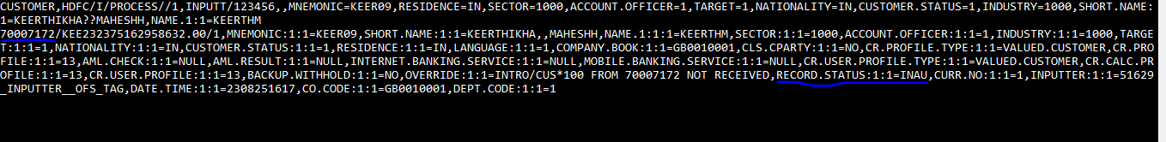



NAU PROCESING = 1

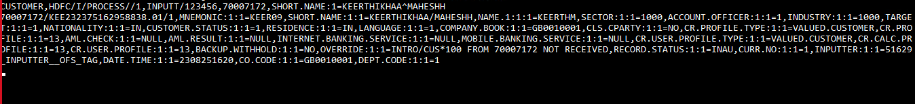

AA.ARRANGEMENT.ACTIVITY,/I/PROCESS/,INPUTT/123456,,ARRANGEMENT=NEW,ACTIVITY:1:1=LENDING-NEW-ARRANGEMENT,EFFECTIVE.DATE:1:1=20220419,CUSTOMER:1:1=100100,PRODUCT:1:1=PERSONAL.LOAN,CURRENCY:1:1=USD,

PROPERTY:1:1=COMMITMENT,FIELD.NAME:1:1=AMOUNT:1:1,FIELD.VALUE:1:1=1000,FIELD.NAME:1:2=TERM,FIELD.VALUE:1:2=12M,

PROPERTY:2:1=SCHEDULE,FIELD.NAME:2:1=ACTUAL.AMT:1:1,FIELD.VALUE:2:1=1000,

PROPERTY:3:1=SETTLEMENT,FIELD.NAME:3:1=PAYIN.ACCOUNT:1:1,FIELD.VALUE:3:1=89699,FIELD.NAME:3:2=PAYOUT.ACCOUNT:1:1,FIELD.VALUE:3:2=89699

Mandatory field

* Arrangement
* Activity
* Effective date
* Customer
* Currency

AA.ARRANGMENT using OFS

Applications that get updated by inputting the arrangements

1. AA.ARRANGEMENT
2. AA.ARRANGEMENT.ACTIVITY
3. AA.ARR.XXX

WORKSHOP: Creating record for AA.ARRANMENT for account

AA.ARRANGEMENT.ACTIVITY,/I/PROCESS/,INPUTT/123456,,ARRANGEMENT=NEW,ACTIVITY:1:1=ACCOUNTS-NEW-ARRANGEMENT,EFFECTIVE.DATE:1:1=20220419,CUSTOMER:1:1=100105,PRODUCT:1:1= NEGOTIABLE.ACCOUNT,CURRENCY:1:1=USD,PROPERTY:1:1=OFFICERS,FIELD.NAME:1:1=PRIMARY.OFFICER:1:1,FIELD.VALUE:1:1=1,FIELD.NAME:1:2=OTHER.OFFICERS:1:2,FIELD.VALUE:1:2=2, FIELD.NAME:1:3=OFFICER.ROLE:1:3,FIELD.VALUE:1:3=Approval

ROUTINE

1. OFS.REQUEST.MANAGER
2. OFS.PARSER.OFS
3. OFS.ENQUIRY.MANAGER
4. OFS.BULK.MANAGER
5. OFS.PROCESS.MANAGER
6. OFS.SESSION.MANAGER
7. OFS.DE.REQUEST

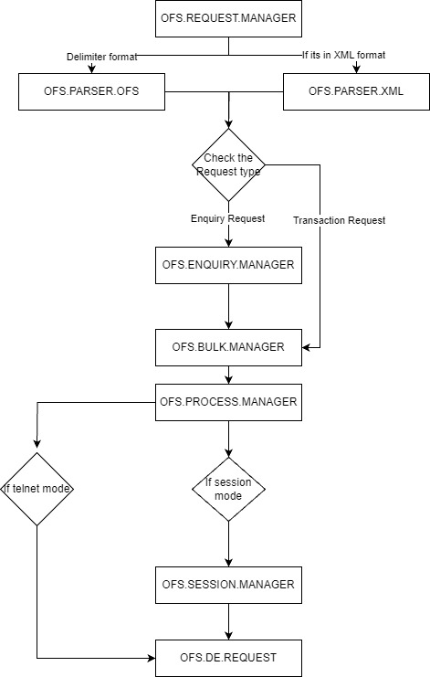

Deleting multivalve String:

ACCOUNT,/I/PROCESS//0,INPUTT/123456,122777,OTHER.OFFICER:2:1=-

LOGESH & KRISHNAN:

Agenda:

1. Sub and multi value creation and deletion
2. AA in OFS
3. special character
4. //
5. how to use comma version in ofs, is it possible – NOT POSSIBLE
6. ofs security
7. ORD -
8. wrapping messages with tags
9. multi company processing

Sub and multi value creation and deletion:

ONE MULTIVALUE - (NULL)

TWO MULTIVALUE - (-)

ACCOUNT,/I/PROCESS//1,INPUTT/123456,,CUSTOMER=100100,CATEGORY=1001,CURRENCY=USD,OTHER.OFFICER:1:1=NULL



AA.ARRANGMENT using OFS

Applications that get updated by inputting the arrangements

1. AA.ARRANGEMENT
2. AA.ARRANGEMENT.ACTIVITY
3. AA.ARR.XXX

WORKSHOP: Creating record for AA.ARRANMENT for account

Request:

AA.ARRANGEMENT.ACTIVITY,/I/PROCESS/,INPUTT/123456,,ARRANGEMENT=NEW,ACTIVITY:1:1=ACCOUNTS-NEW-ARRANGEMENT,EFFECTIVE.DATE:1:1=20220419,CUSTOMER:1:1=100105,PRODUCT:1:1= NEGOTIABLE.ACCOUNT,CURRENCY:1:1=USD

Response:

o/p id: AA22109W0XKL

AAACT22109HMRWVXQ2

AA.ARRANGEMENT.ACTIVITY,/I/PROCESS/,INPUTT/123456,,ARRANGEMENT=NEW,ACTIVITY:1:1=ACCOUNTS-NEW-ARRANGEMENT,EFFECTIVE.DATE:1:1=20220419,CUSTOMER:1:1=100105,PRODUCT:1:1= NEGOTIABLE.ACCOUNT,CURRENCY:1:1=USD,PROPERTY:1:1=OFFICERS,FIELD.NAME:1:1=PRIMARY.OFFICER:1:1,FIELD.VALUE:1:1=1,FIELD.NAME:1:2=OTHER.OFFICERS,FIELD.VALUE:1:2=2, FIELD.NAME:1:3=OFFICER.ROLE:1:3,FIELD.VALUE:1:3=Approval

// Concept:

LD.LOANS.AND.DEPOSITS,CORPORATE/I/PROCESS/1,INPUTT/123456,,CUSTOMER.ID=100100,CURRENCY=USD,AMOUNT=10,FIN.MAT.DATE::=20230420,INTEREST.RATE::=3.13,CATEGORY=21059,DEFINE.SCHEDS::=YES//FORWARD.BACKWARD::=4,BASE.DATE.KEY::=3,SCH.TYPE:1:1:=B,DATE:1:1:=20230415,AMOUNT:1=20,SCH.TYPE:2:1:=IP,DATE:2:1:=20230420,AMOUNT:2=30

Special character:

|  |  |
| --- | --- |
| Actual character | OFS compliant replacement character |
| / | ^ |
| “ | | |
| , | ? |

 CUSTOMER,/I/PROCESS//0,INPUTT/123456,,MNEMONIC=GOPI3433,RESIDENCE=IN,SECTOR=1000,ACCOUNT.OFFICER=1,INDUSTRY=1000,TARGET=1,NATIONALITY=IN,CUSTOMER.STATUS=1,SHORT.NAME:1=  
NISHANTHKUMAR,NAME.1:1=NISHAN?^,FURTHER.DETAILS="bx",LANGUAGE=1